**T1** 2023

Coverity Scan Static Analysis Report

Hardhard Enterprises

Statement of Intent

Overview

This document aims to provide a record of static code analysis performed on a specific issue from the Coverity SAST scan for the NASA ION Open-Source code 4.1.1 project.

The primary purpose of this document is to validate the issue identified via the automated detection process to eliminate false positives.

Depending on findings, secondary purposes can include but are not limited to listing/providing recommended fixes alongside a list of attack vectors and potential exploits for consideration.

Reporting Best Practices

Please ensure best practices are kept when completing the document via regularly updating the Acronyms and Abbreviations table alongside any iterations made to the Document History table. This will allow other members to identify any updates and progress made across trimesters easily.

When using code snippets, please use screenshots that are clear and easy to read, alternatively, use words built-in code formatter found [here](https://appsource.microsoft.com/en-us/product/office/WA104382008?tab=Overview).

Document Naming Conventions

Naming conventions for this file are as follow; SAR_{CID}. For example, when investigating issue 123456 the file name would be SAR_123456.docx

Document History

|  |  |  |  |
| --- | --- | --- | --- |
| **Dates** | **Version** | **Author** | **Comments** |
| 6/9/2023 | V0.1 | Tahlea Grant | Document beginning |
|  |  |  |  |
|  |  |  |  |

Table of Content

Contents

Introduction 3

Objective 3

Scope 3

Acronyms and Abbreviations 3

Code Review and Analysis 4

Outcomes 4

Observations 4

Supporting Evidence 4

Conclusions and Recommendations 5

References 6

Appendix 7

# Introduction

## Objective

The primary objective of this analysis is to determine whether the defects identified in the Coverity Report for the ION Open Source 4.1.1 project are:

* Indeed, defects.
* Potentially exploitable.

The secondary objective of this analysis, where applicable, is to provide the following:

* Recommendation(s) to fix.
* Any exploit for consideration.

## Scope

This static code analysis is limited to the *API Usage* - arguments in wrong order identified in the following CIDs:

***1520771***

# Acronyms and Abbreviations

Please keep an updated list of acronyms and abbreviations used throughout the report.

|  |  |
| --- | --- |
| **Acronym** | **Meaning** |
| DTN | Delay/Disruption Tolerant Network |
| ION | Interplanetary Overlay Network |
|  |  |

# Code Review and Analysis

## Overview

The error related to the order in which arguments are passed, and they have been passed in the wrong order and result in an unintended effect which negatively impairs the functionality of the function.

## Observations

“qualifiedFileName” is being passed as the first argument, “sizeofqualifiedFileName” is passed as the second and “stringBuf” is passed as the third to the “getQualifiedFileName” function. Which is causing an error. “The positions of arguments in the call to getQualifiedFileName do not match the ordering of the parameters:qualifiedFileName is passed to pathNameBuf.stringBuf is passed to fileName.’’

## Supporting Evidence

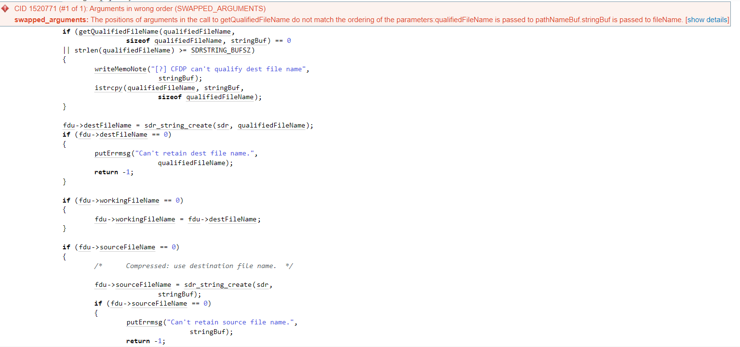

# 

# Conclusions and Recommendations

After reviewing the “getQualifiedFileName” function the order of the variables is meant to be pathNameBuf, bufLen and fileName.



Therefore, I think if sizeof qualifiedFileName and stringBuf variables are swapped the error should be rectified.



References  
Please keep an updated references list in APA7; The Deakin referencing guide can be found [here](https://www.deakin.edu.au/__data/assets/pdf_file/0009/2236752/Deakin-guide-to-APA7.pdf).

Appendix

Include additional information/documentation here to help the readers understand complex information.